+880 1953546089 |  | Patuakhali | sharafatkarim@proton.me
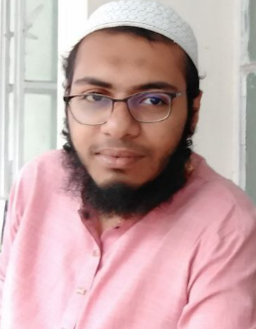
Curriculum vitae of
Md. Sharafat Karim
Personal |  | Father  Mother  Religion  Nationality | Ayoub Moharof Hossain  Sahinoor Akter  Islam (Sunni)  Bangladeshi
Address |  | Present  Permanent | Kolatola Bazar,  Patuakhali, Barishal  Rasulpur Sawmill  Matlab, Chandpur
Contact |  | Website  Email  Mobile  GitHub profile | sharafat.pages.dev  sharafatkarim@proton.me  +880 1953546089  github.com/SharafatKarim
Education |  | From 2021 | Patuakhali Science and Technology University  Computer Science and Engineering
 |  | 20219-2021 | Notre Dame College  Science
 |  | 2014-2019 | Shamsul Hoque Khan School  General science

Professional training |  | 2023-Present | Basic networking  CISCO web
 |  | 2023 | AutoCAD electrical basics  Tutorialspoint web
 |  | 2022 | Basic python programming  Codecademy
Professional affiliations |  | 2020-Present | Linux Bangla  Linux bases community Bangladesh
 |  | 2019-2020 | NDEC  English improvement course
Professional service |  | 2022-Present | Arch User Repository  Maintainer
 |  | 2020-Present | Linux Universe Community  Admin

Technology |  | Version Control | Git  GitHub
 |  | Web  Platform  Graphics  Office Suite | Hugo  HTML  Bootstrap  GNU/Linux  Windows NT  Adobe Creative Suite  Inkscape  Blender 3D  LibreOffice

Languages |  | Bangla | Native language
 |  | English | Intermediate Listener, Novice Speaker, Advanced Reading and Writing
Computer skills |  | Programming | C  Python  Bash scripting
 |  | Applications | Office  Vector design  Motion animation
 |  | Platforms | GNU/Linux
References |  | Saifur Rahman  Tamim | NextGen Solution  Professional web developer  And .NET developer
sharafat
-------------------------
Signature

